# Sign-Up Form

Create a Web page (HTML5 + CSS3) that looks and behaves like the screenshot below:

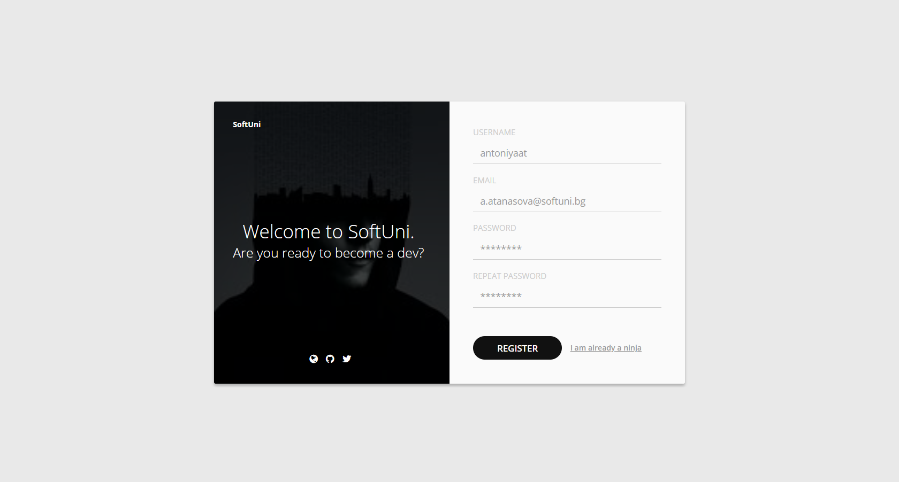

### Output

The output should be valid **HTML5** + **CSS3** + **images** that implement the above web page.

### Constraints

* Use the Google font - "**Open Sans**";
* Use **Font Awesome** for the icons
* The site should open correctly in the latest version of Chrome